[Date]



Aung Tun Lin

Std id- 00557

COS 210 Assignment

.Net Programing with C#

Table of Contents

**Short Summary on Fitness Gym** 3

**Database Design** 5

**Test Plan** 9

**Welcome, Login, Registration and Enrollment Coding** 12

**Admin Forms** 17

**Test Data & Result of All Forms** 26

30

Database Connection Design

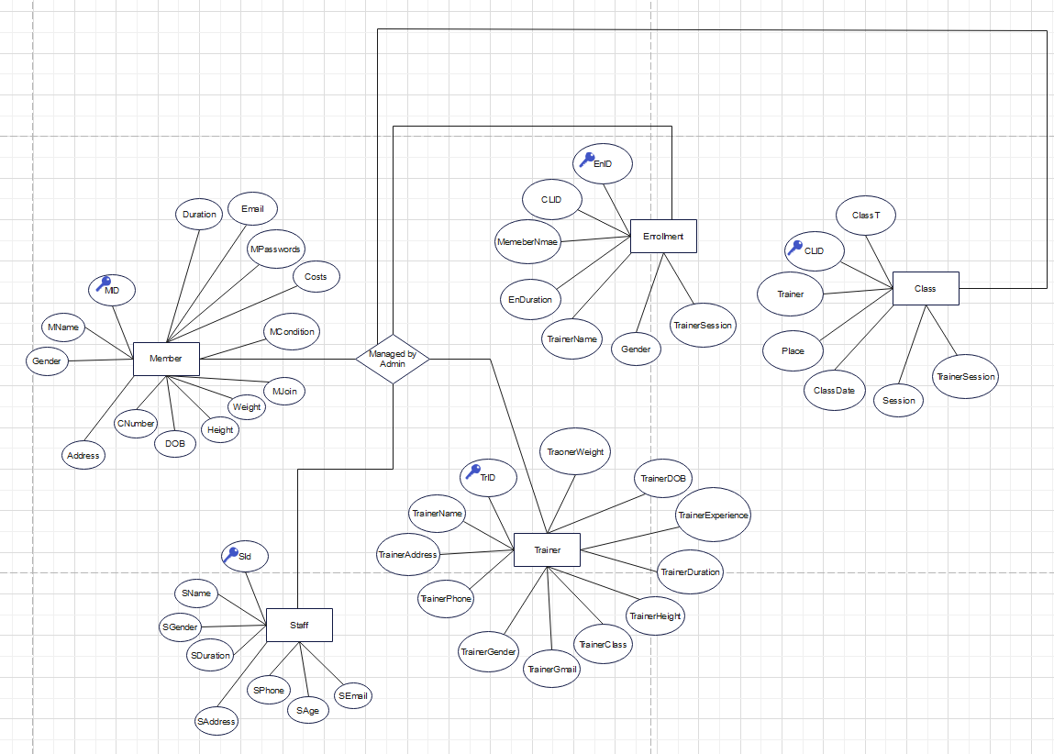

# **Short Summary on Fitness Gym**

Regular exercise encourages health and wellbeing. Youth who exercise regularly have better muscular growth, bone strength, weight management, mental wellness, and academic success. Children who participate in regular physical activity are more likely to maintain active lives into adulthood and are less likely to acquire risk factors for chronic illnesses like heart disease and type 2 diabetes than those who do not. Physical fitness is a state of being that correlates with both current and long-term health outcomes and represents a person's capacity for doing particular tasks or activities. Youth fitness testing has developed into a well-established institution in school physical education programs over the past 50 years, despite the fact that the fitness components tested and the individual test items included in protocols have varied significantly among test batteries and over time. 2012. Youth Health Outcomes and Fitness Measures.

In this Application, we examine how technology may (and does) make it easier to exercise at Gym, how it can inspire individuals to start and maintain an active lifestyle, and how it can be successful in producing outcomes (such as improved strength and balance).

**Member Registration Form**



**Member ID**

**Member Name**

**Password**

**Contact Number**

**Email**

**Address**

**Date of Birth**

**Have you ever joined**

**Height**

**Weight**

**Health issues**

**Fees**

Gym Forms firmly think that submitting your forms online (as Web Forms) is the most effective and ecologically responsible course of action. Gym registration forms are soft copies paperwork that will gather the necessary data from a person who wants to utilize the gym. His basic information such as Name, Password, Contact Number, Email, Address, Date of birth, experience, height, weight and chosen payment method, and the schedule of gym classes he/she chooses to use are among the details that the Gym registrant or Member will reveal. Additionally, some gyms will also keep records of pertinent medical information on their members or registered gym-goers in order to understand the limitations or restrictions of the members. Gym Forms assist anybody working in the fitness business, including gym owners, fitness instructors and Admin.







Access of Database

**What Does Admin Do ?**

View, Search, Update, Delete

View, Search, Update, Delete

View, Search, Insert, Update, Delete

View, Search, Insert, Update, Delete

View, Search, Insert, Update, Delete

**Member**

**Class**

**Trainer**

**Staff**

**Enrollment**

# **Database Design**

**User Admin Table Database**

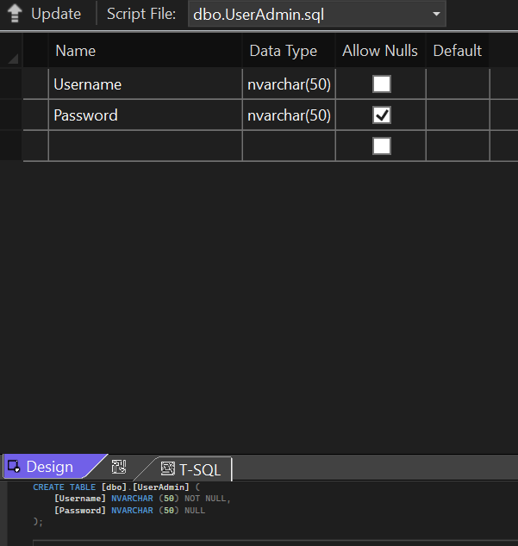

In this database table, Open Table Definition consists of two Dataset name Username and Password consisting of nvarchar (50) Data type.

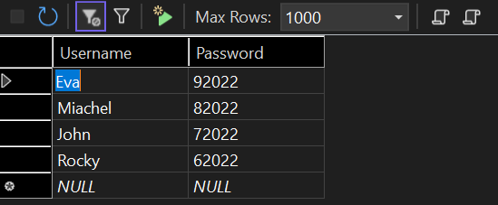

In this database table, the show table consists of 4 usernames (Eva, Miachel, John, Rocky) and the Password for them are shown in the snap shot. This data is to login for the old user.

**Member Table Database**

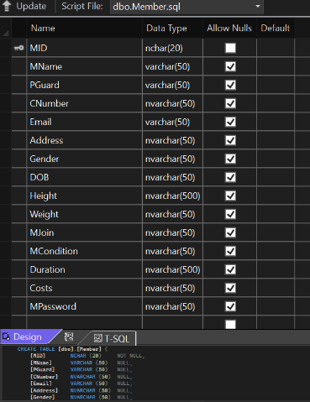

In this database table open definition Consists of ID, Name, Parent Guardian, Contact number, email, address, gender, DOB, Height, Weight, Joining Experience, Condition, Duration, Costs and Passwords with the nvarchar data type. The primary key is also set for the MID for the auto increment and the decrement

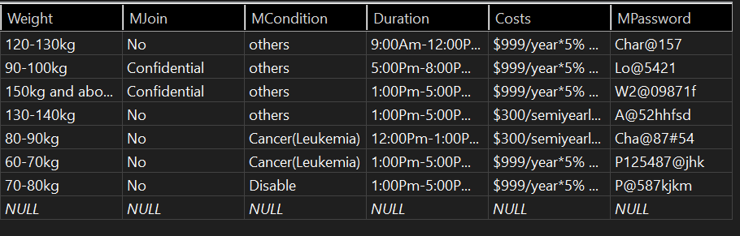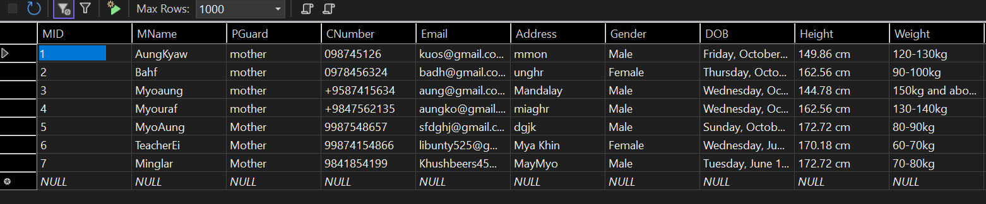

This data table consists of data taking place in the Dataset shown in the snap shot.

**Trainer Table Database**

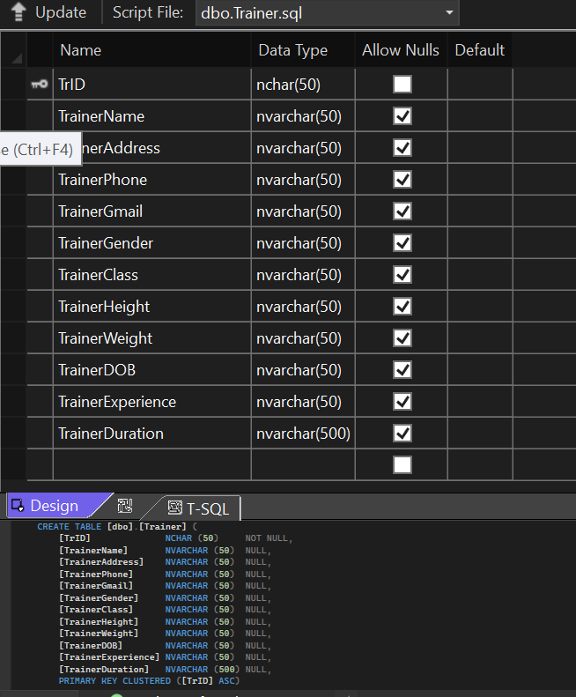

In this database Table Open definition, Consists of Trainer ID, Name, Address, Phone number, Gmail, Gender, Class, Height, Weight, DOB, Experience and Duration with nvarchar data type. Trainer ID is also set for its primary key for its increment operation and decrement operation.

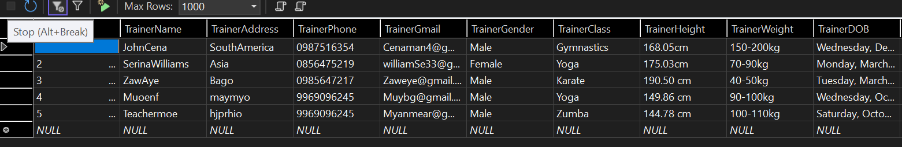

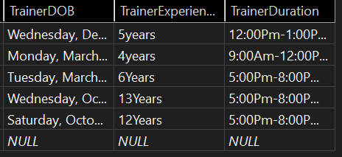This data table consists of data taking place in the Dataset shown in the snap shot.

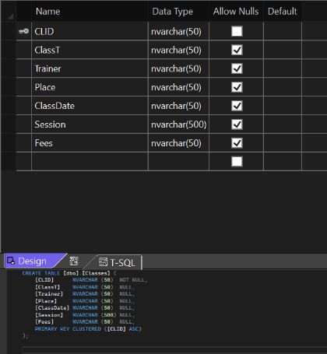**Class Table Database**

In this Database Table open definition, Consist of Class ID, Class Titles, Trainer, Place, Class Date, Session and Fees with the nvarchar data type. Class ID is also set for its primary key for its increment operation and decrement operation.

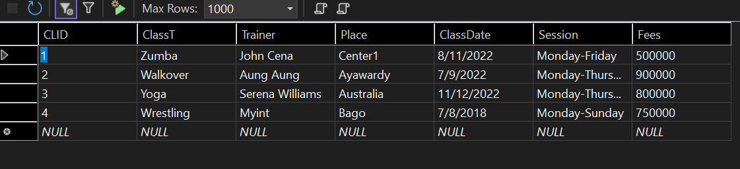

This data table consists of data taking place in the Dataset shown in the snap shot.

**Staff Table Database**

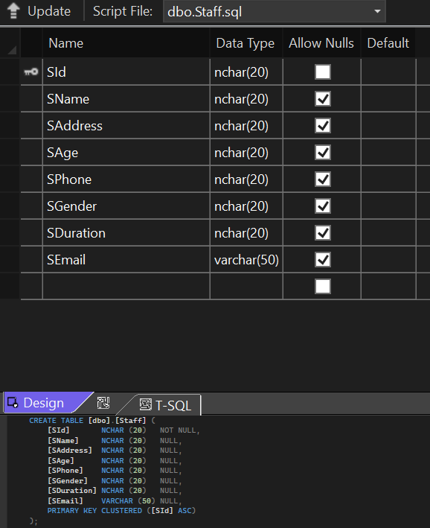

In this Database Table open Definition, consists of Staff ID, Name, Address, Age, Phone Number, Gender, Duration and Email with nvarchar and varchar datatype. Staff ID is also set for its primary key for auto increment and decrement operations

This data table consists of data taking place in the Dataset shown in the snap shot.

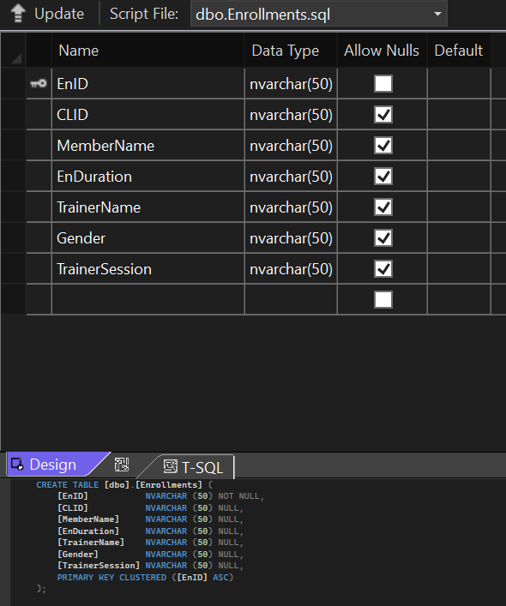**Enrollment Table Database**

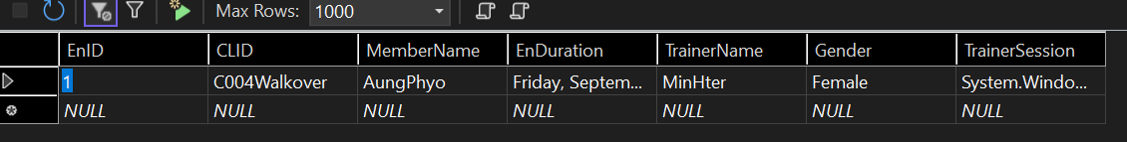In this Database Table open Definition, consists of Enrollment ID, Class ID, Member Name, Enrollment Duration, Trainer Name, Gender, Trainer Session with nvarchar data type.

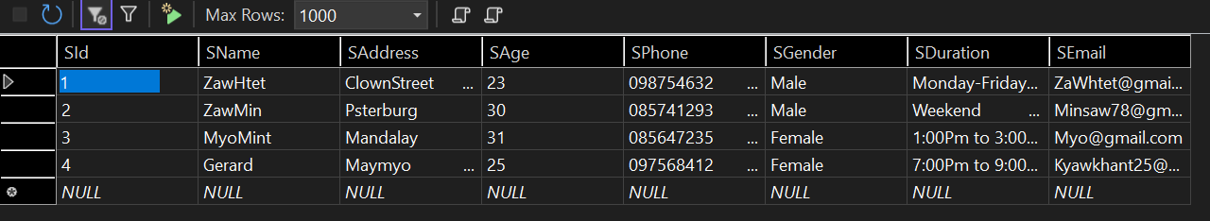

This data table consists of data taking place in the Dataset shown in the snap shot.

**Taking Snapshot of all the interface forms in the BUC Assignment**

# **Test Plan**



**Project**

This is the Welcome Form representing the “Welcome to Gym Class” with the white caption and Login and Registration button. After you clicked the Login button it will connected to Login (Form2). Likewise, after you clicked the registration, it will connect to Registration (i.e., Form3)

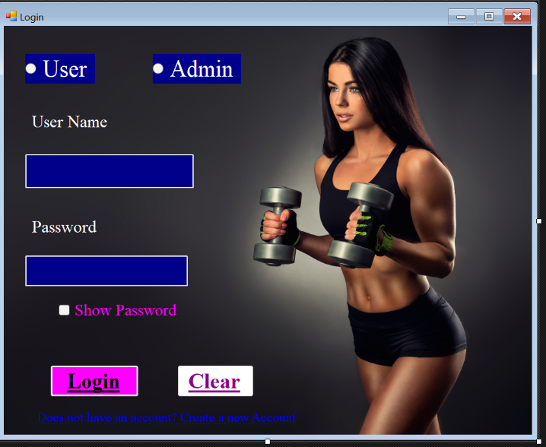**Login Form**

After you clicked the login the button it will connected to Login Form shown in the snapshot. It consists of two radio button one for the User and the Admin. If the admin has to login, he/she have to choose one of the above options by entering correct username and Password. It will be the same way as old user want to login. There is clear button given in the form to reset the data. Below the Clear button it gives the connection if the user does not have an account.

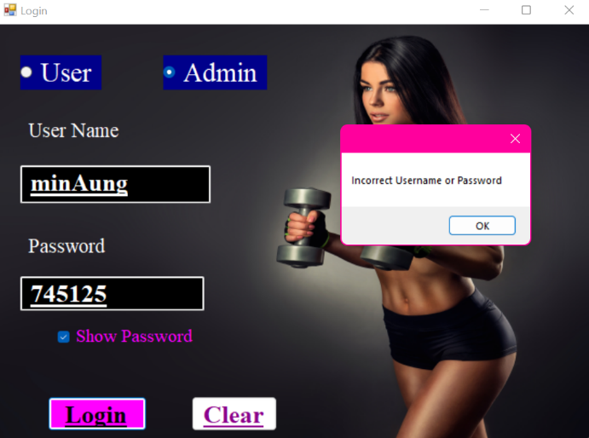

If the Admin type the incorrect username and password that does not much to the Database it will show a Message box consisting “Incorrect Username or Password.

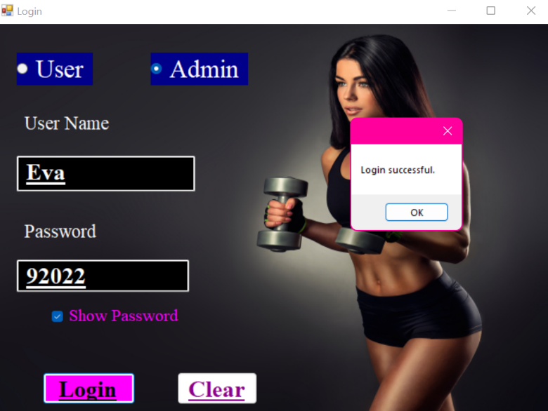

If the Admin type the correct username and password that much to the Database it will show a Message box consisting “Login Successful”. After you click OK, it will connect to Admin Interface contain view, update, delete, insert and search button.

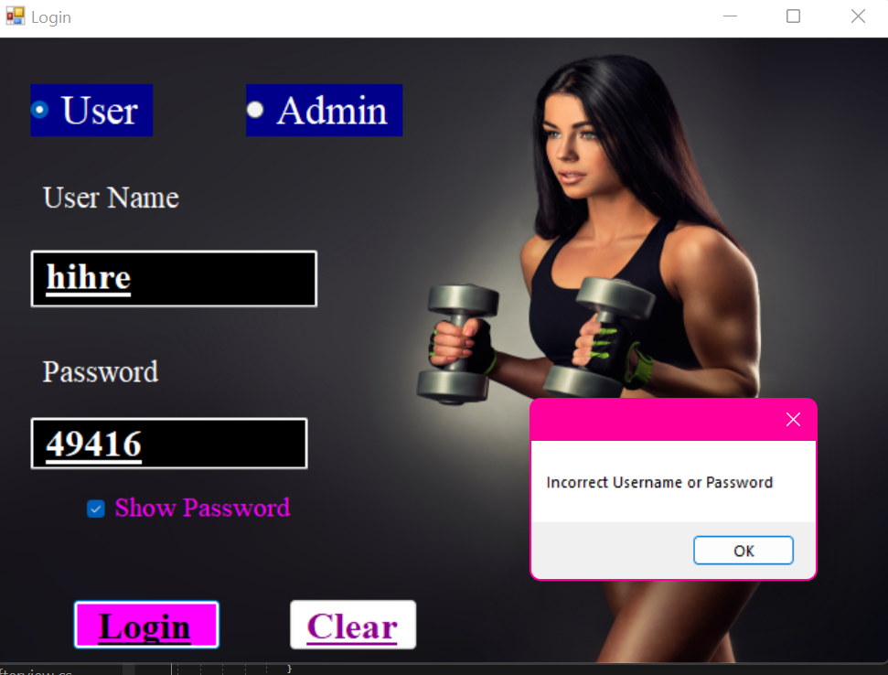

If the User type the incorrect username and password that does not much to the Database it will show a Message box consisting “Incorrect Username or Password.

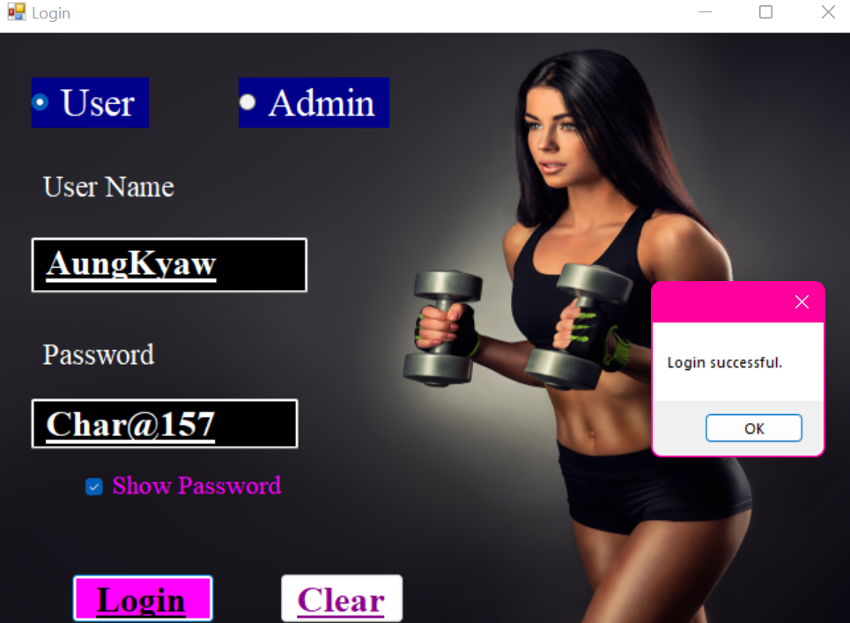

If the User type the correct username and password that much to the Database it will show a Message box consisting “Login Successful”. After you click OK, it will connect to Enrollment Form which will described later.

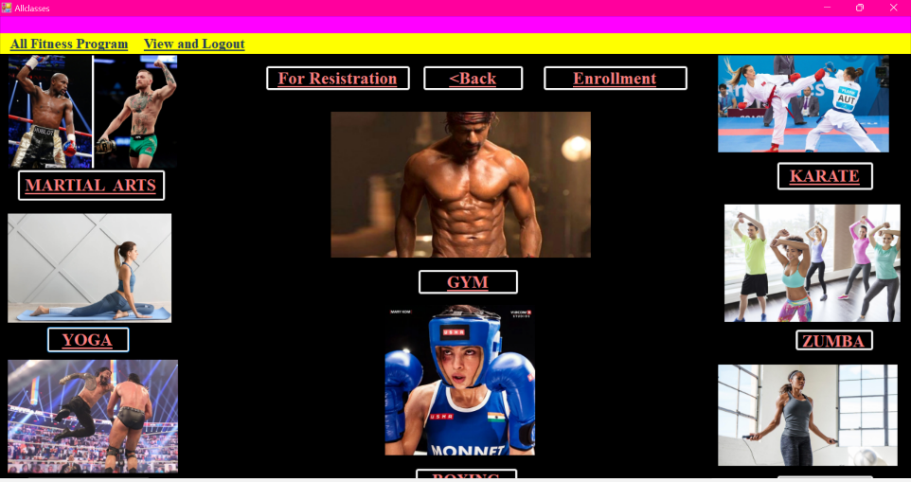From following Welcome form if the new user selects Registration it will connected to All classes form consists of “For Registration”, “Back button” and “Enrollment”. If the user click view and Logout menu script it will move Welcome Form.

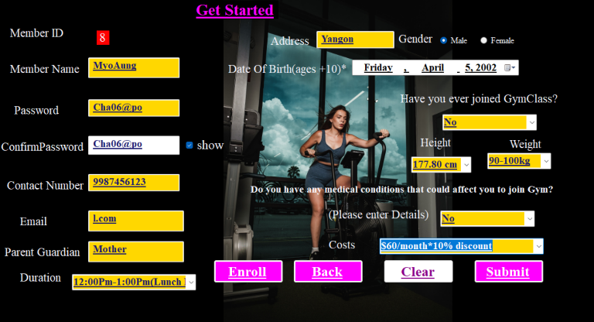 This is the Registration Form in which the user has to enter the required information. This all the information has some validation like for the Member Name you cannot proceed to enter the rest of the data until you the first capital letter is implemented. Likewise, for the Password it requires at least one Character, Number, Big Letter and small Letter. The email may be incomplete if you not enter the procedure needed for email due to its validation. The Contact number must not have less than ten number because of its validation which will descried with the coding page.

After the user add complete information by surpassing all the validation it will proceed to Enrollment Form1.

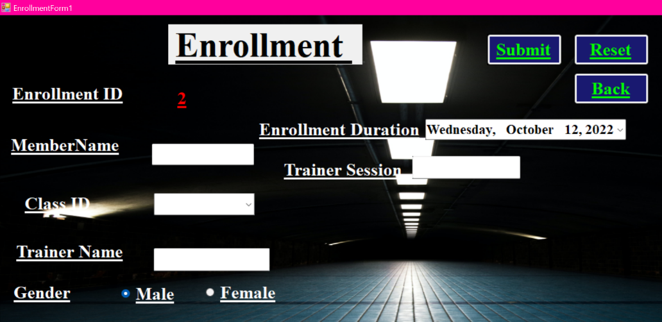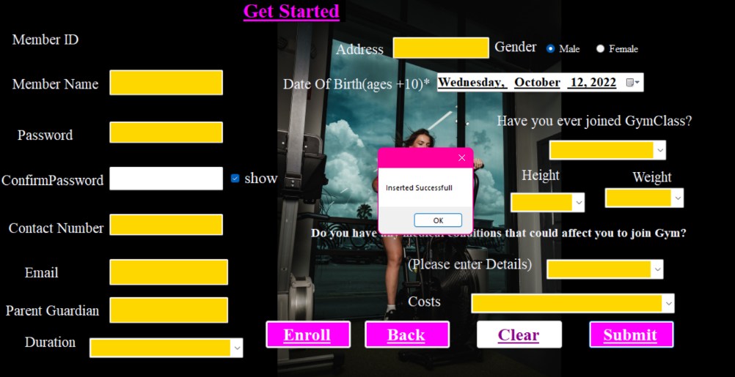Here is the Enrollment form to submit the Data with all the validation.

# **Welcome, Login, Registration and Enrollment Coding**

* **Welcome Form Coding**

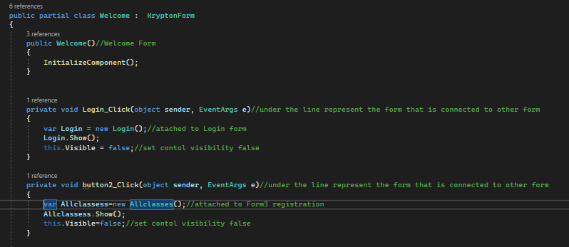

# 

* 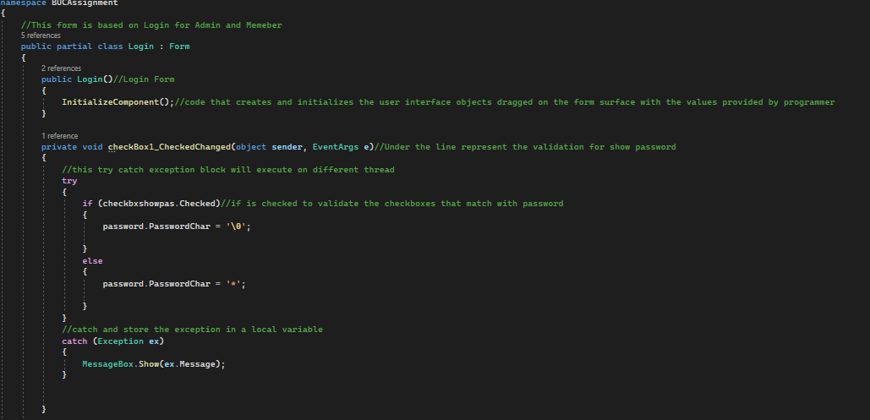**Login Form Coding**
* For Check Password Coding and using exception handler

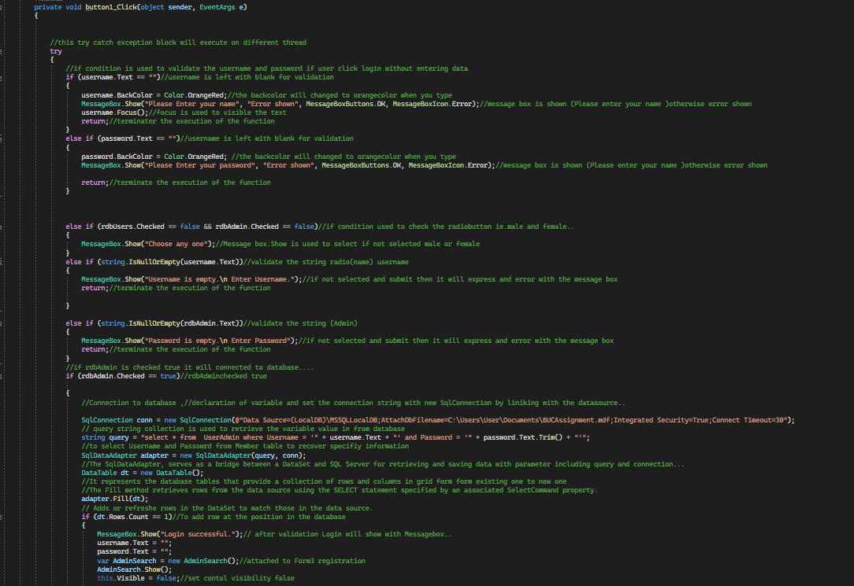

* Using try catch handler and validation for radio button, Name and Password
* Using try catch handler and validation for radio button, Name and Password

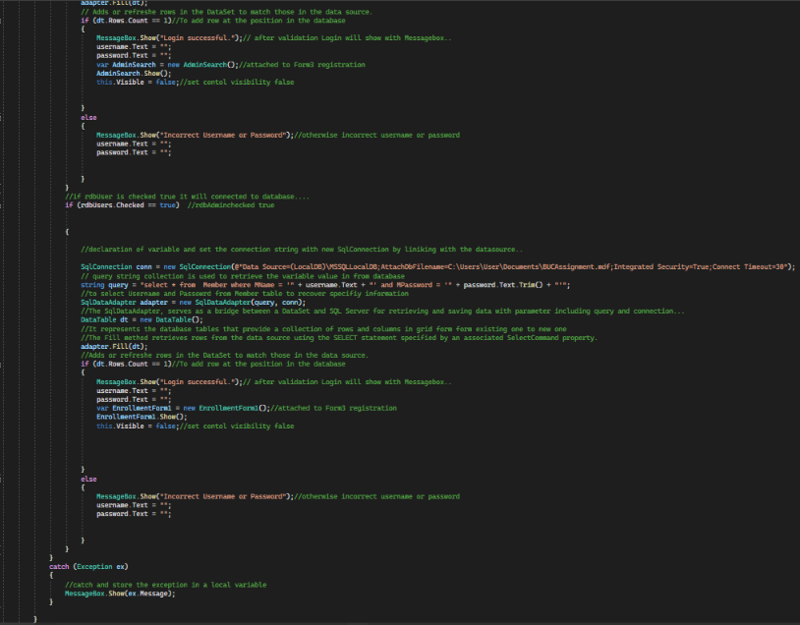

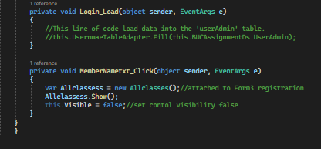

* Form connection login button and Back Button
* **Registration Form Coding**

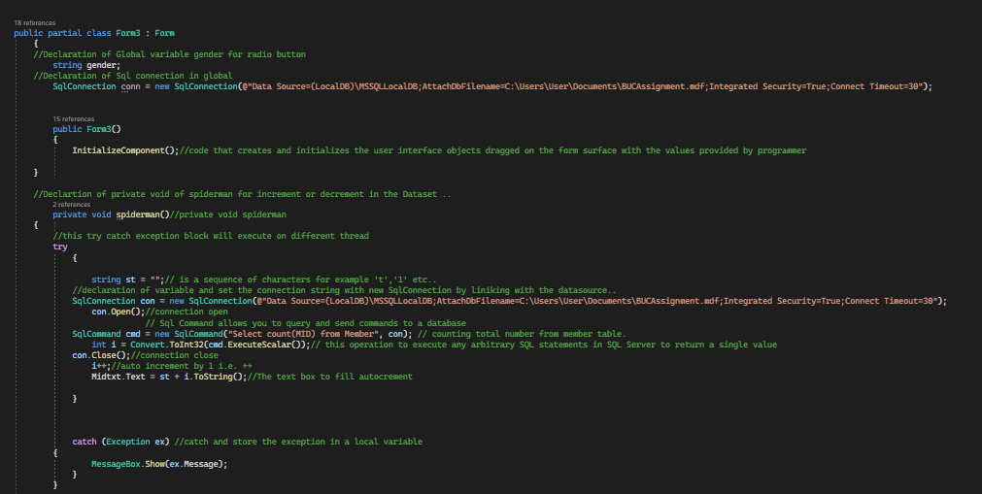

* Auto increment Coding
* 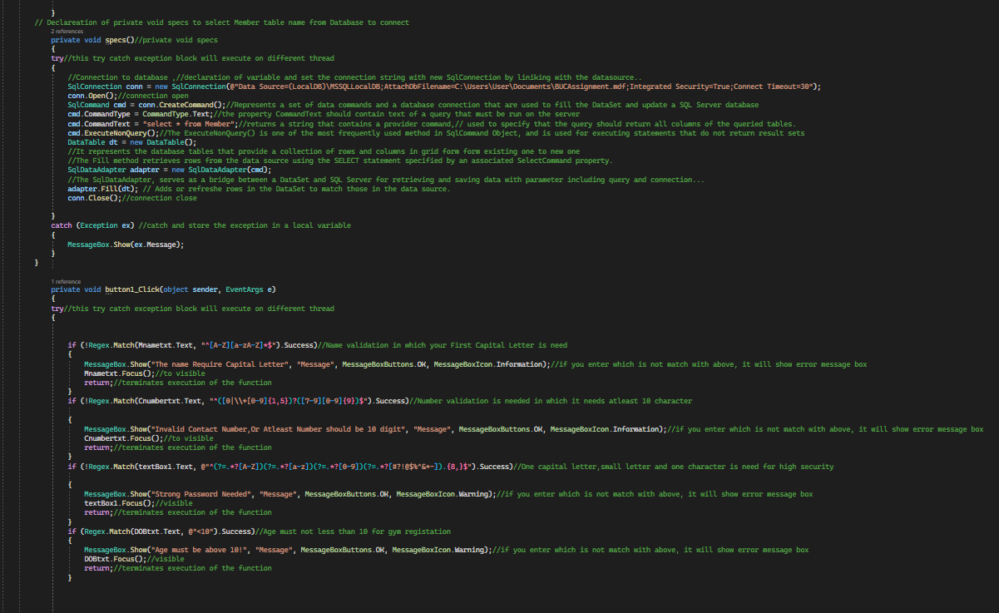using exception handler and validation for Name, phone number, Password, Gmail and all the other data information.

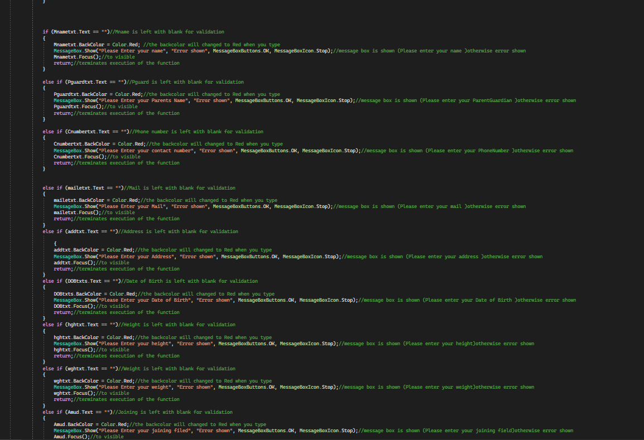

* using exception handler and validation for Name, phone number, Password, Gmail and all the other data information.

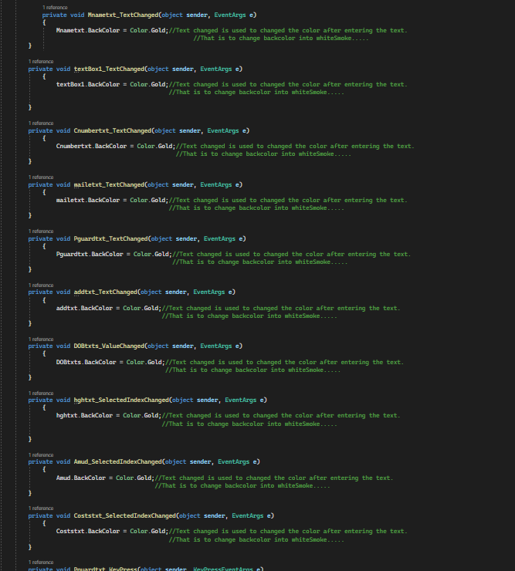

* changing back after you type
* 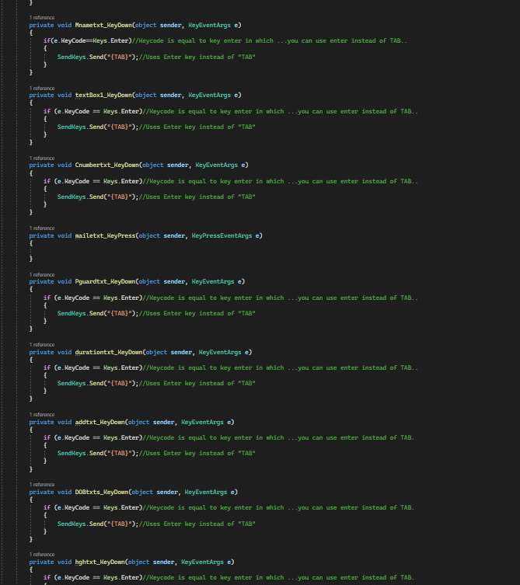All the data will tab from one text box to another after entering “Enter” key.

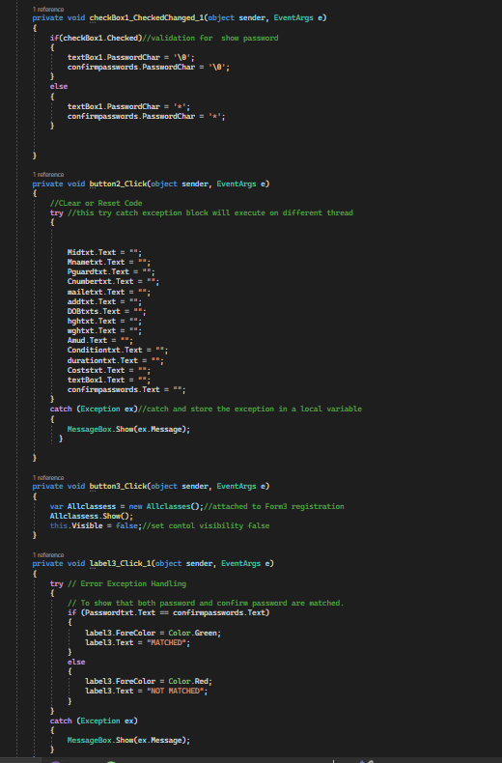

* Code for Show Password by using exception handler. Form connection by Registration button and Back Button. Code for Reset is also used for clear the data in the form.
* **Enrollment Form Coding**

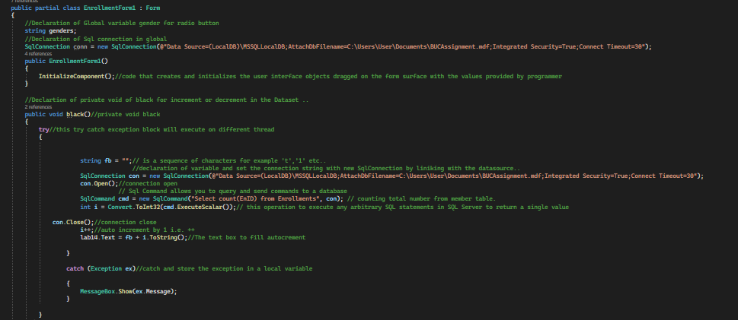

* Auto increment Coding using exception handler.
* using exception handler and validation for Name, phone number and all the other data information 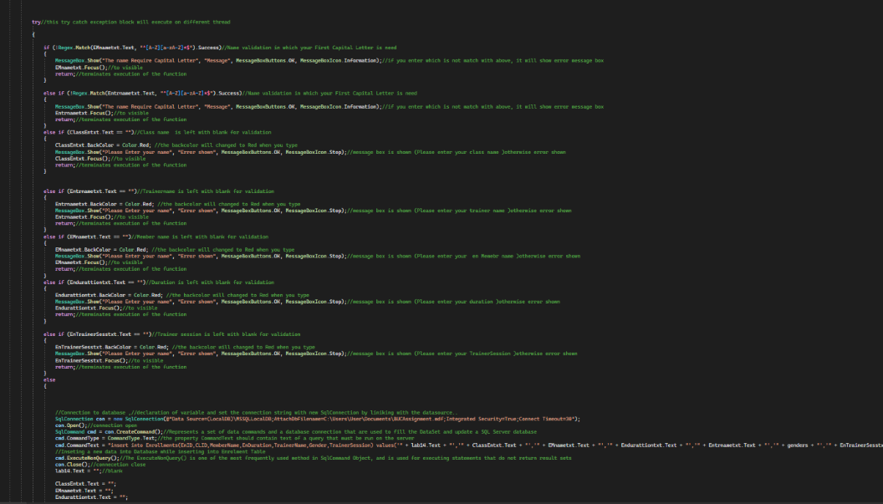.Coding for database connection

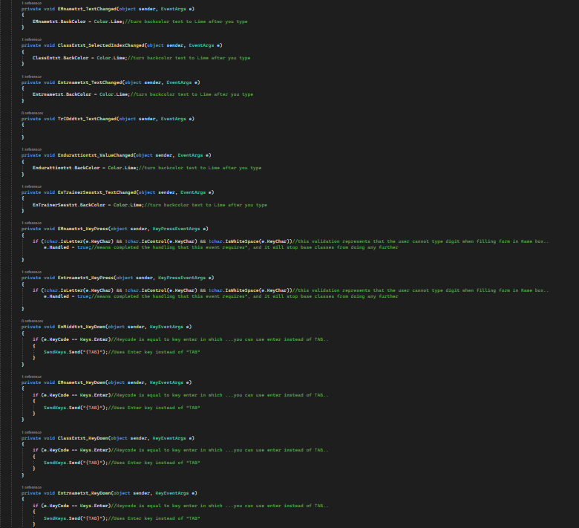

* All the data will tab from one text box to another after entering “Enter” key.

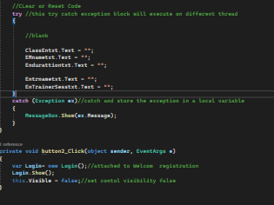

* Form connection by Submit button and Back Button. Reset button is also used for clearing the data

# **Admin Forms**

* **Admin Login Form**



Admin Login is the place where Admin Member can get an admission to access the personal details of Staff, Trainer, Member, Enrollment and Class. The administrator can access the customer sites.

* 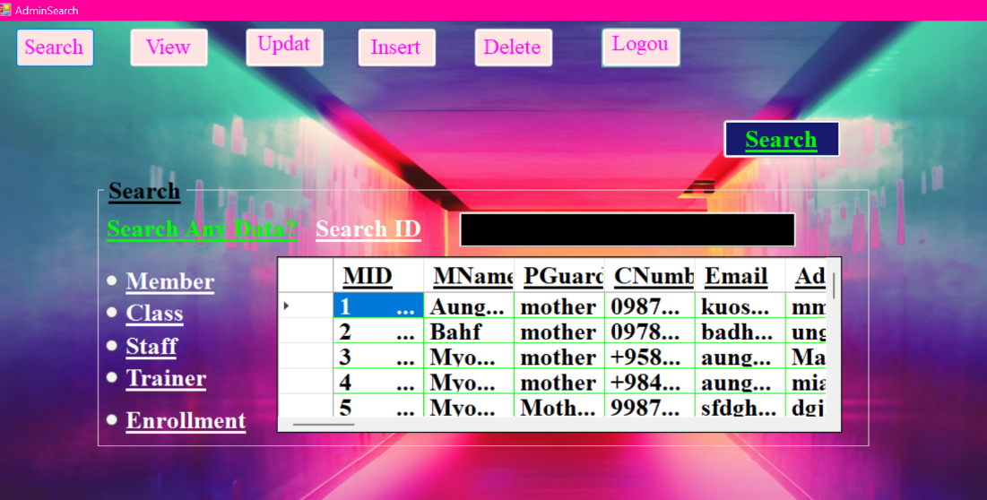**Admin Search Form**

The administrator can Search Member, Class, Staff, Trainer, Enrollment information by searching only ID in the given box. The admin must select one of those radio buttons given in the form then click Search button to proceed.

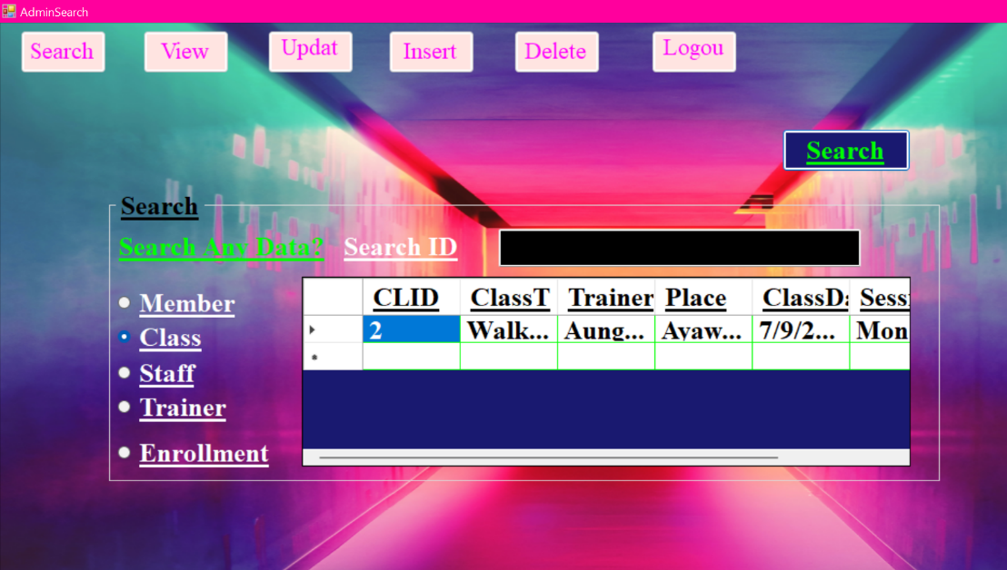

The administrator selects class radio button and enter 2 in the given black box and the click search button. After selecting 2 the data will show only class ID of 2 in the given respective grid view.

* **Admin View Form**

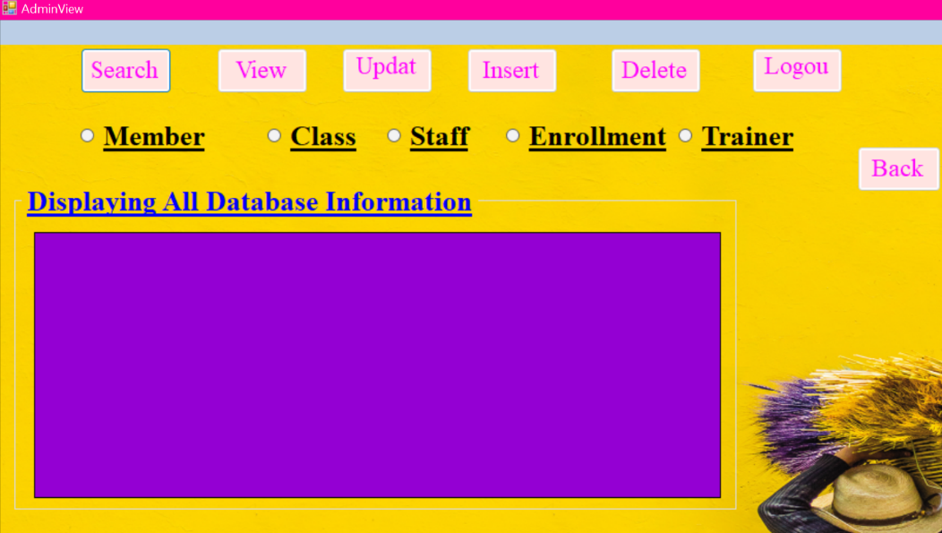

This is the Admin View Form in which Admin can Select any of the Database given in the form for its displaying in respective data Grid View. The back button is also used to go back in the Search Form.

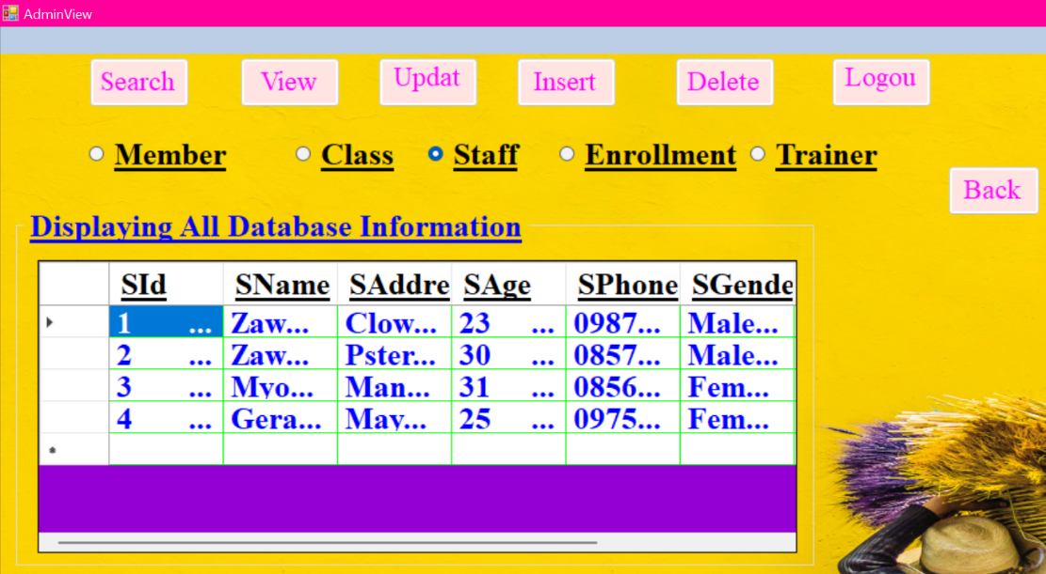

As soon as the administrator select the Staff radio button the data will automatically view in the respective data grid view given in the form.

* **Admin Update Preview Form**

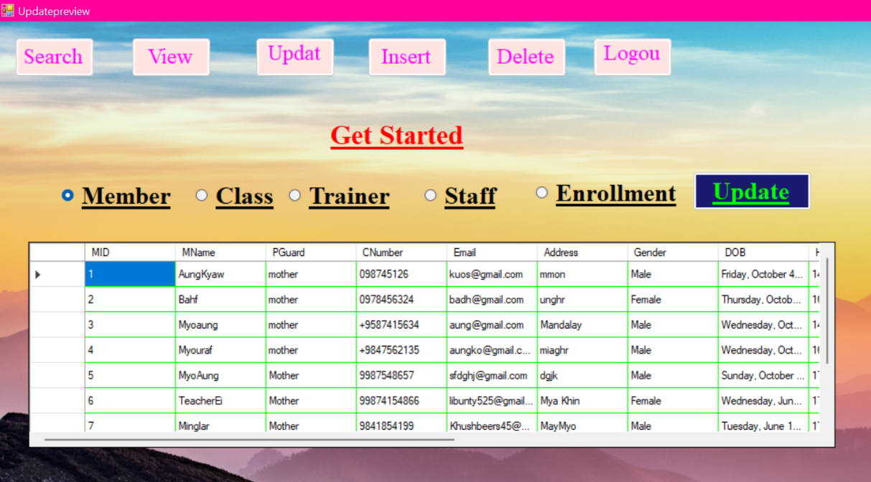This is the Update Preview Form in which Administrator can select any of the following radio buttons to update by clicking Update Button given in the form. For example, if administrator select Member and click the update button then it will take administrator to another form which is related to Member Form. It will be same for Class, Trainer, Staff and Enrollment.

* **Admin Update Form**

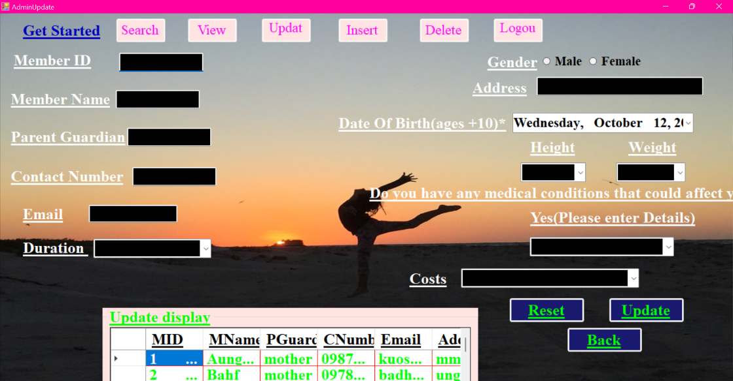

This is the Admin Update Form in which Administrator can update related to Member data. The Reset button in the form is used to clear the data. The back button is used to go back to the update Preview Form.

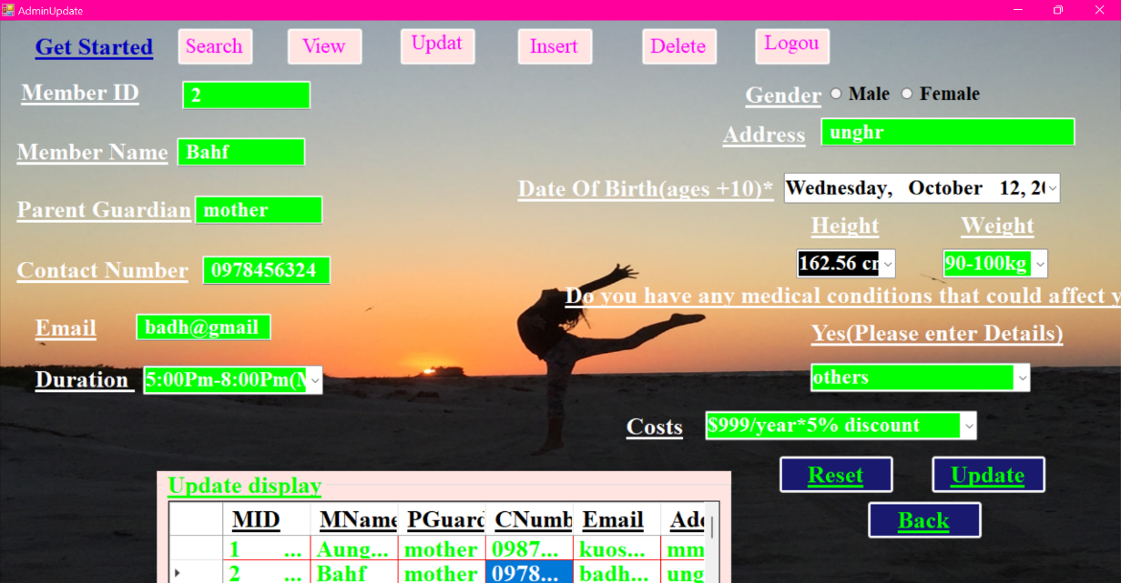If the administrator is bore to type each and every data then he can select data given grid view. After selecting data in the grid view the data will automatically write down in the textboxes.

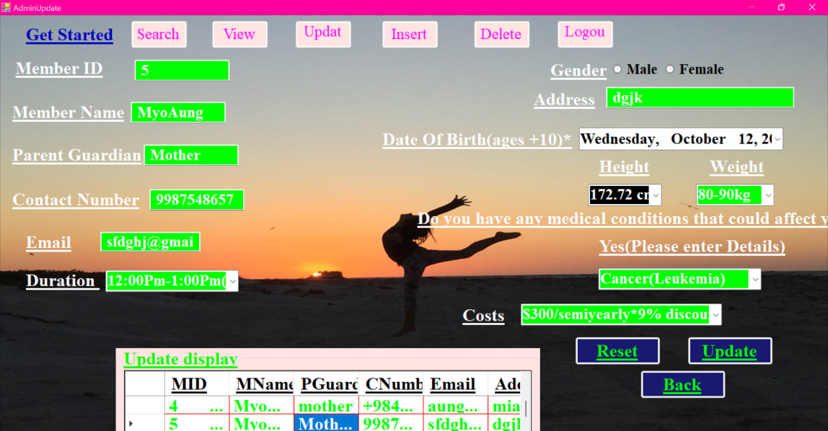

This is the admin update Form in which the administrator has to update the required information. This all the information has some validation like for the Member Name you cannot proceed to enter the rest of the data until you the first capital letter is implemented. Likewise, the email may be incomplete if you not enter the procedure needed for email due to its validation. The Contact number must not have less than ten number because of its validation.

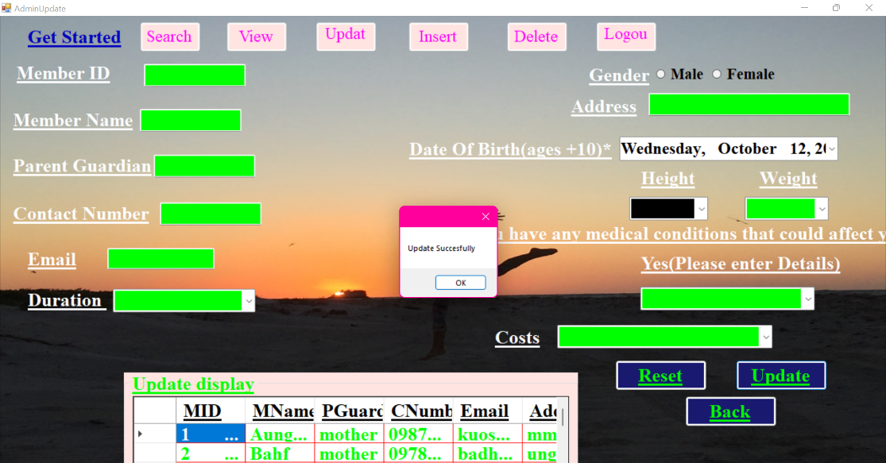After the administrator update complete information by surpassing all the validation it will proceed by updating new data in the respective grid view.

* **Admin Update1 Form**

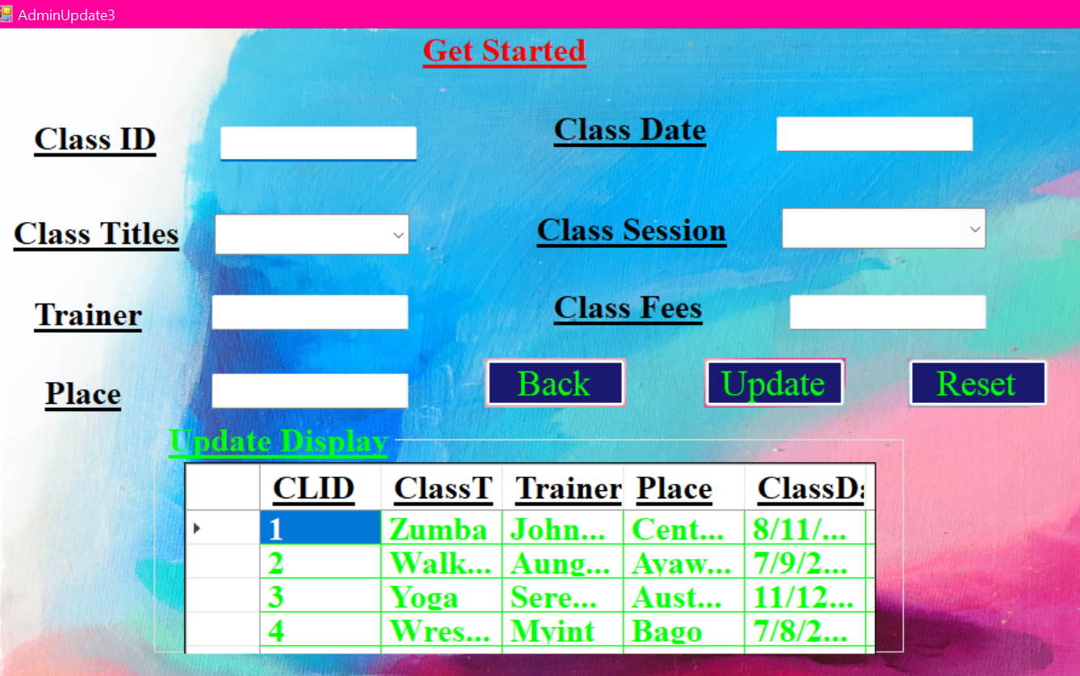

This is the Admin Update Form1 in which Administrator can update related to Class data. The Reset button in the form is used to clear the data. The back button is used to go back to the update Preview Form.

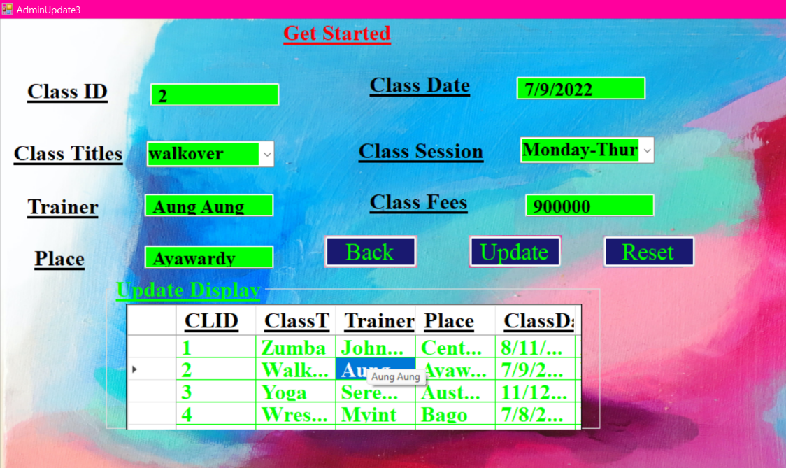

If the administrator is bore to type each and every data then he can select data given grid view. After selecting data in the grid view the data will automatically write down in the textboxes.

This is the admin update Form in which the administrator has to update the required information. This all the information has some validation like for Class titles and trainer name where you cannot proceed to enter the rest of the data until you the first capital letter is implemented.

The process above of update preview and update 1 form will be same as for Trainer, Enrollment and Staff radio button.

* **Admin Insert Form**

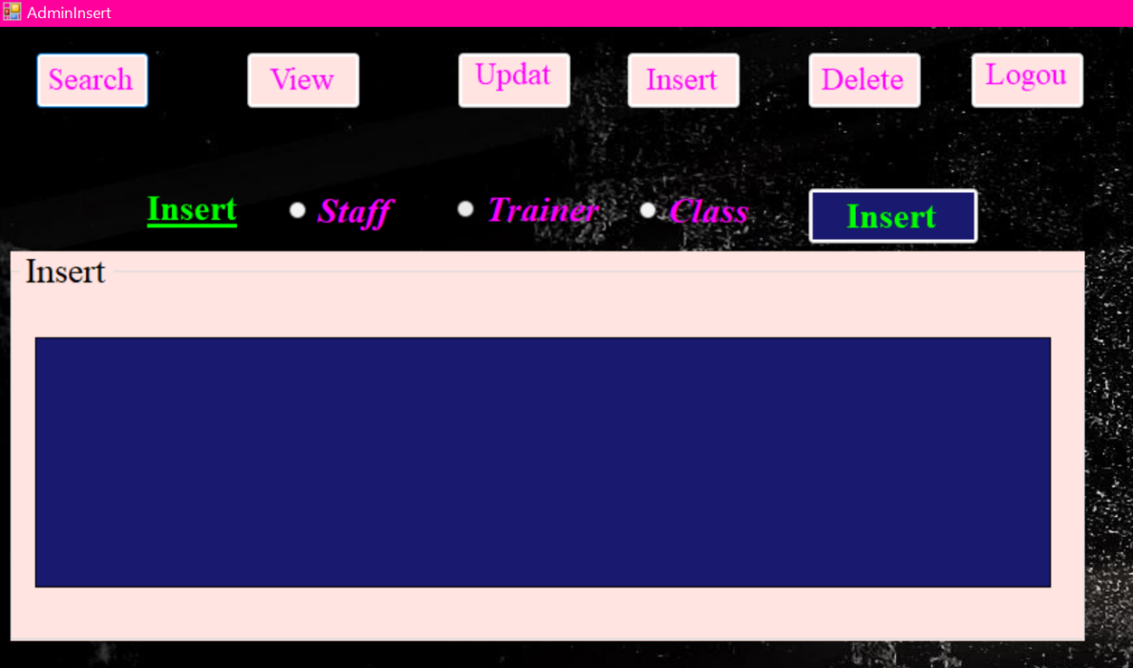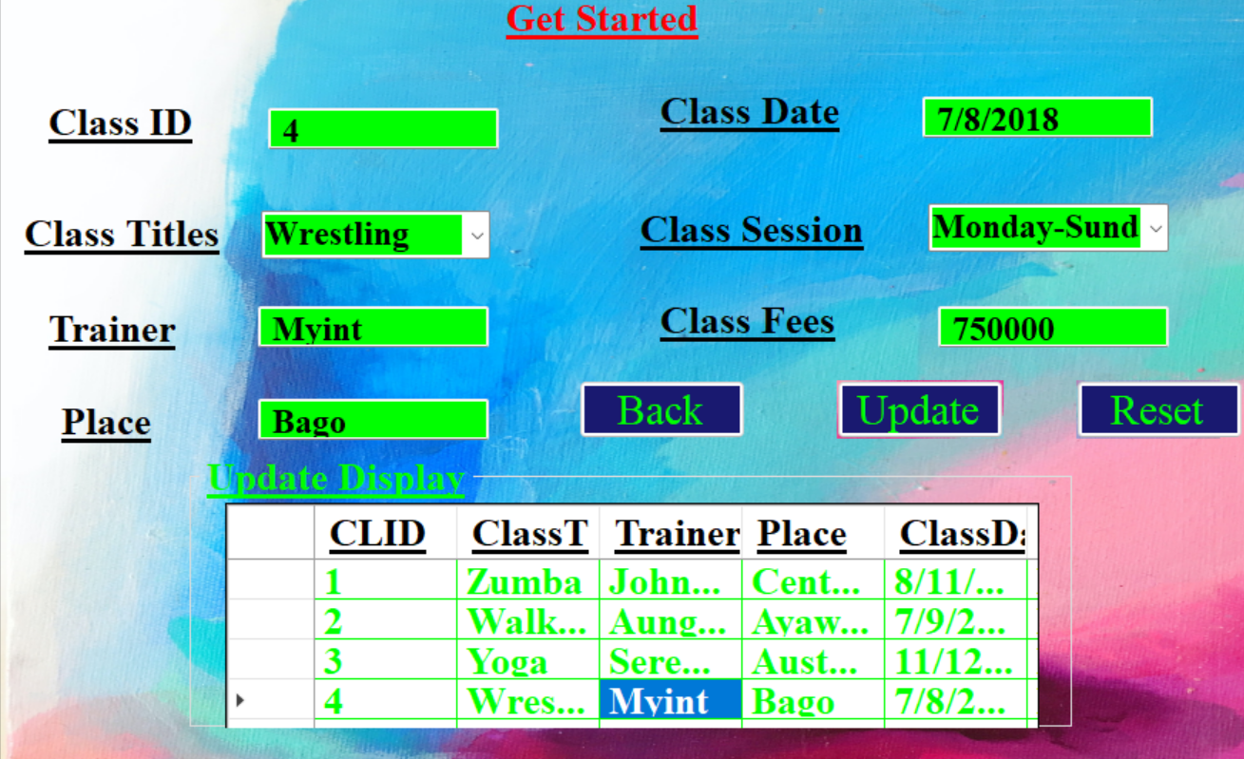

This is the Admin Insert Form in which Administrator can select any of the following radio buttons to insert by clicking Insert Button given in the form.

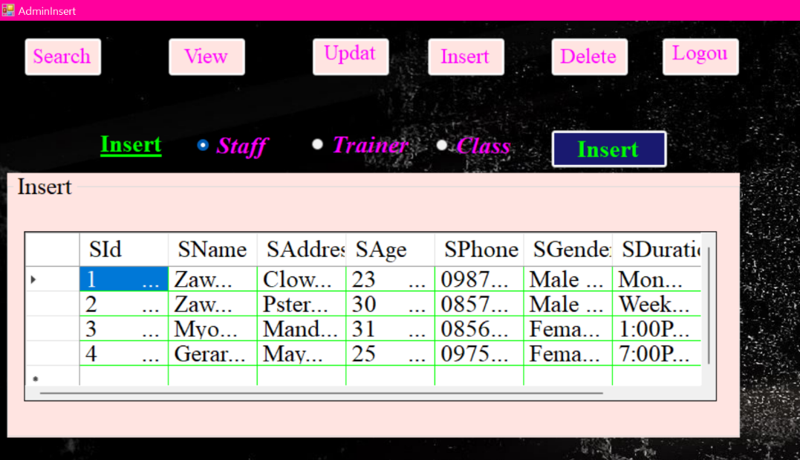In this Form, if administrator select and click the Insert button then it will take administrator to another form which is related to Member Staff Member. It will be same for Class, Trainer.

* **Admin Insert after view Form**

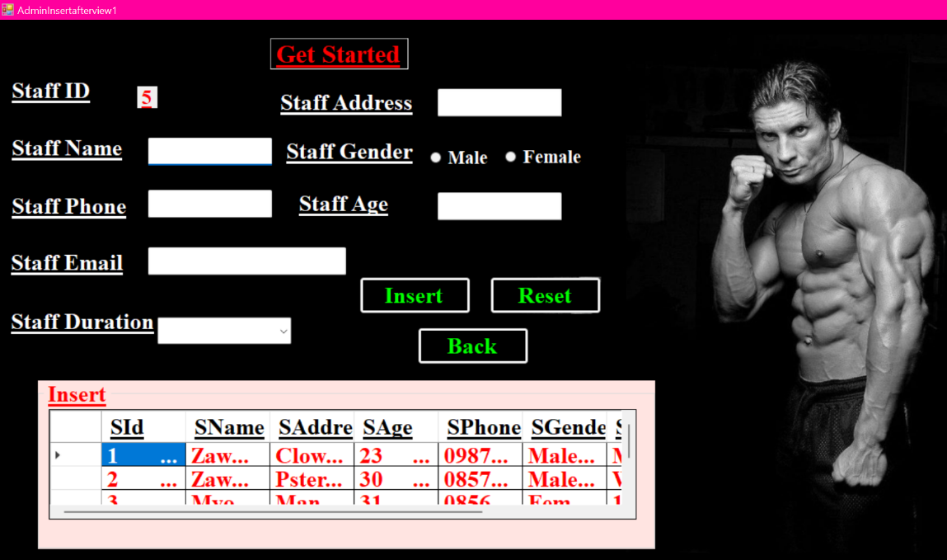

This is the Admin Insert after view 1 in which Administrator can update related to Staff data. The Reset button in the form is used to clear the data. The back button is used to go back to the admin insert Form.

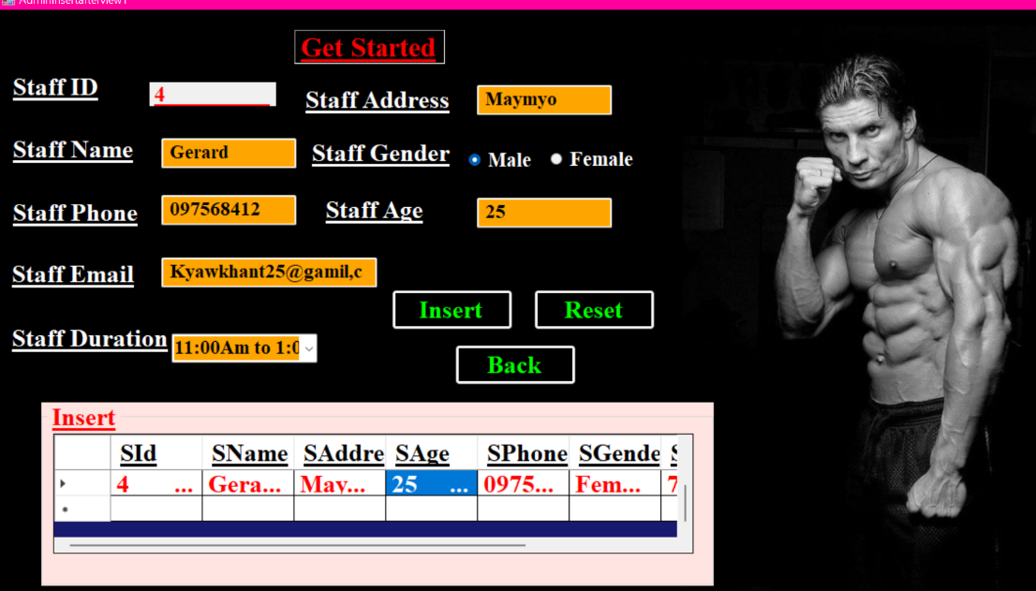

If the administrator is bore to type each and every data then he can select data given grid view. After selecting data in the grid view the data will automatically write down in the textboxes.

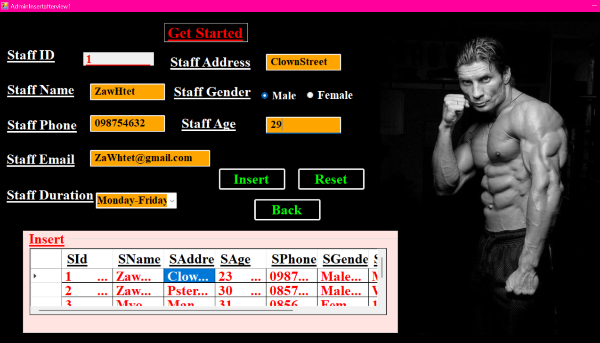

This is the admin Insert after view1 Form in which the administrator has to insert the required information. This all the information has some validation like for Staff Name and Staff Email where you cannot proceed to enter the rest of the data until you the first capital letter is implemented. Likewise, the email may be incomplete if you not enter the procedure needed for email due to its validation. The Contact number must not have less than ten number because of its validation. After that the administrator can insert by clicking Insert button. After clicking Insert button it will added to the database.

The process above of Admin Insert after view1 form will operate same as for Trainer and class radio button.

* **Admin Delete Form**

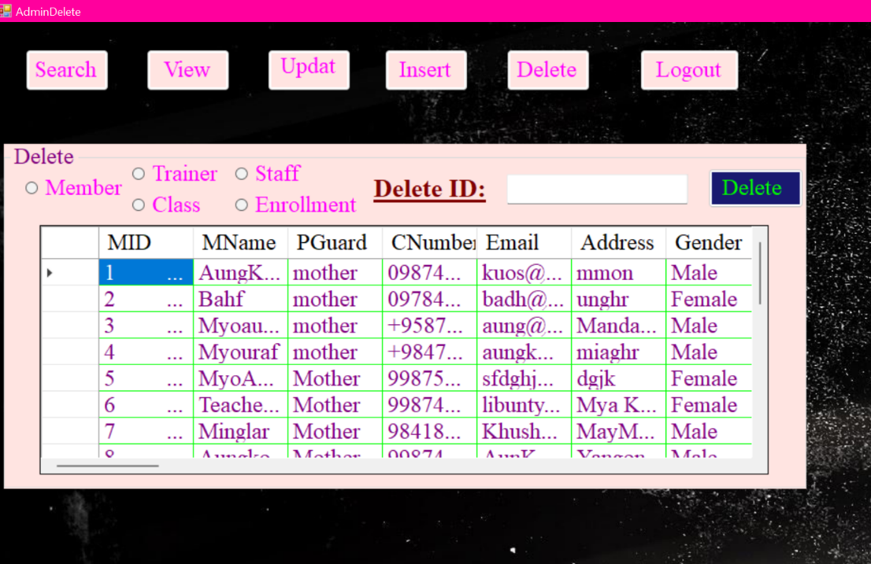

The administrator can Delete Member, Class, Staff, Trainer, Enrollment information by deleting only ID in the given box. The admin must select one of those radio buttons given in the form then click Delete button to proceed.

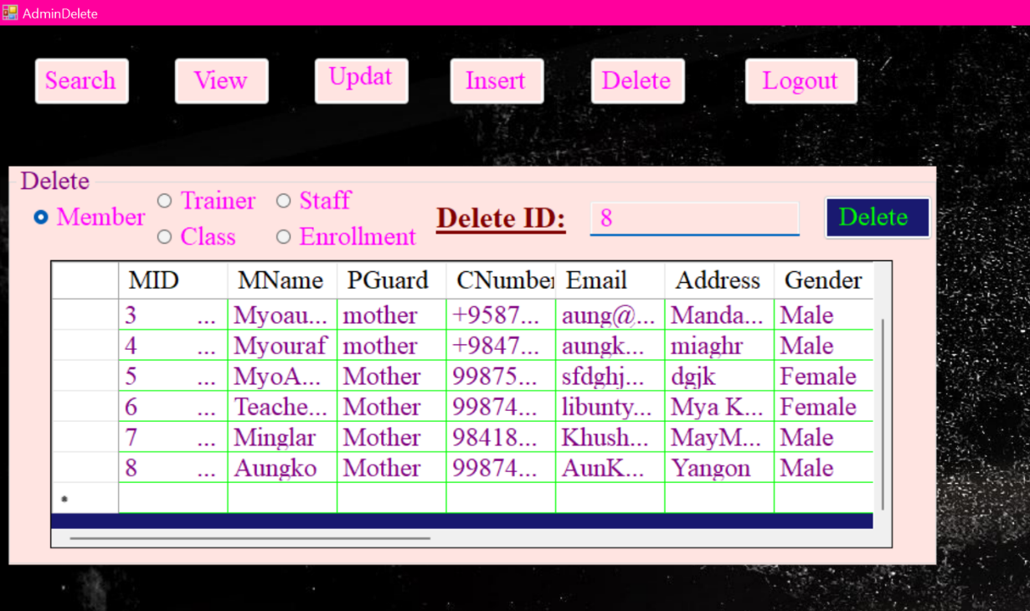The administrator selects Member radio button and enter 8 in the given black box and the click delete button.

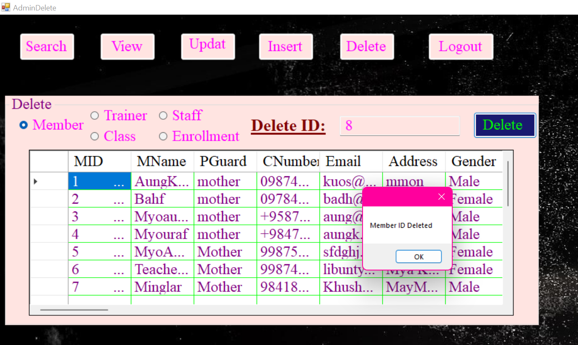

After selecting 8, the data row of 8 Primary key of MID in the given respective grid view of data will be deleted.

# **Test Data & Result of All Forms**

|  |  |  |  |  |
| --- | --- | --- | --- | --- |
| **User Name** | **Fail** | **True** | **Fail** | **True** |
| **Password** | **Fail** | **Fail** | **True** | **True** |
| **Expected Result** | **Error: Please**  **Enter Name** | **Error: Please enter correct Password** | **Error: Please enter correct name** | **Logged in** |

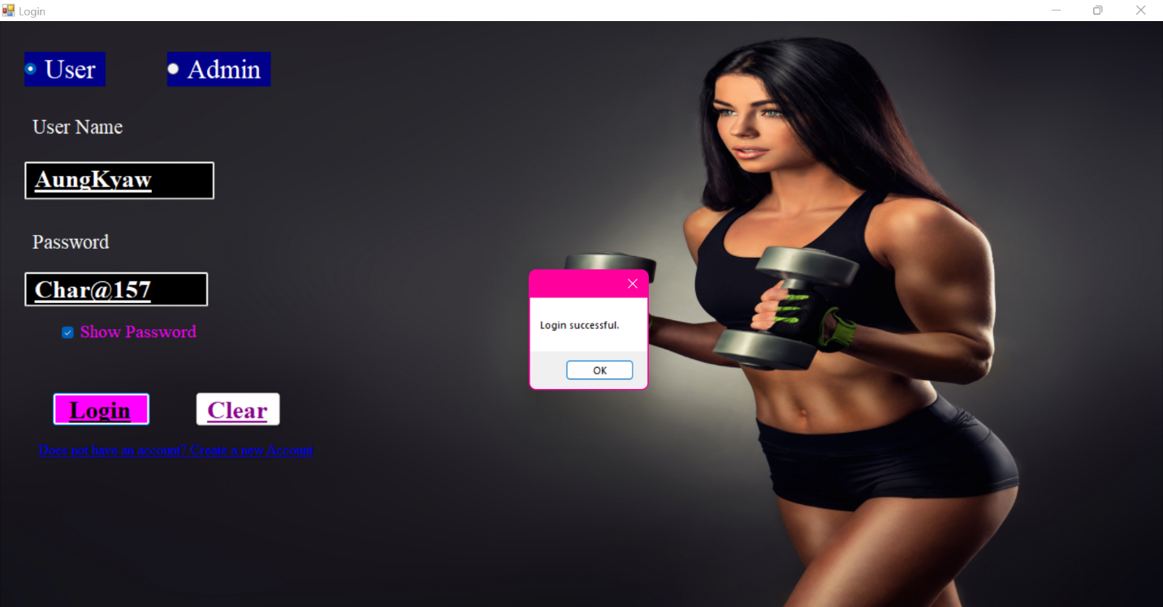

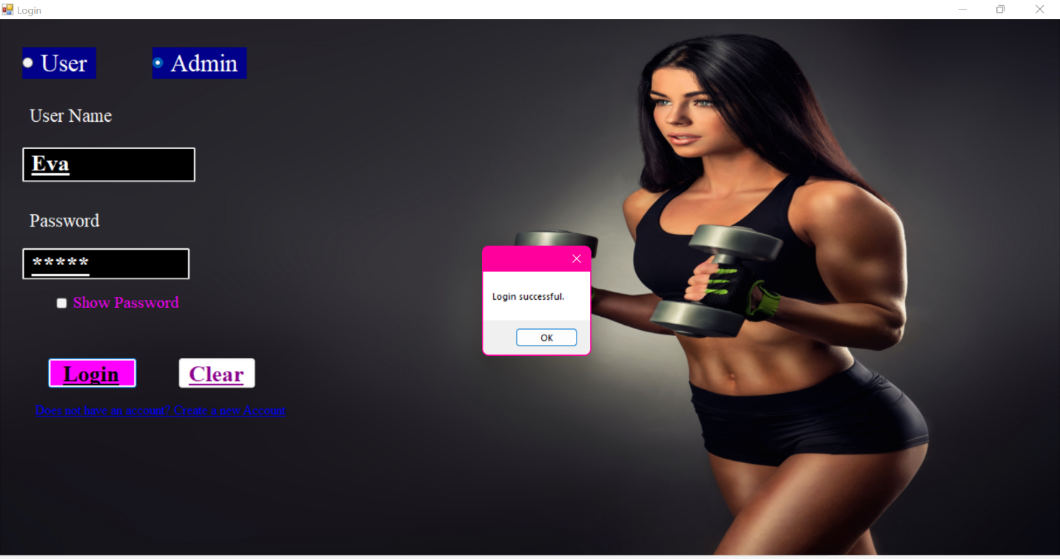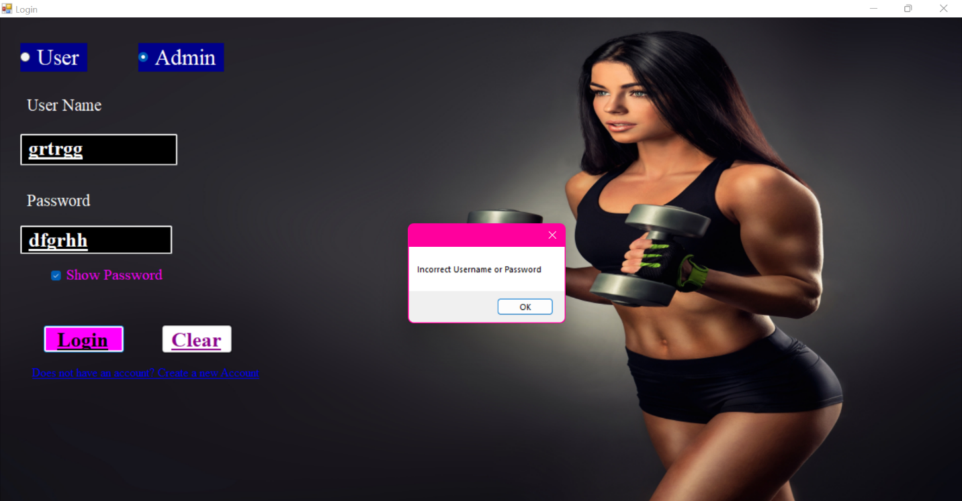

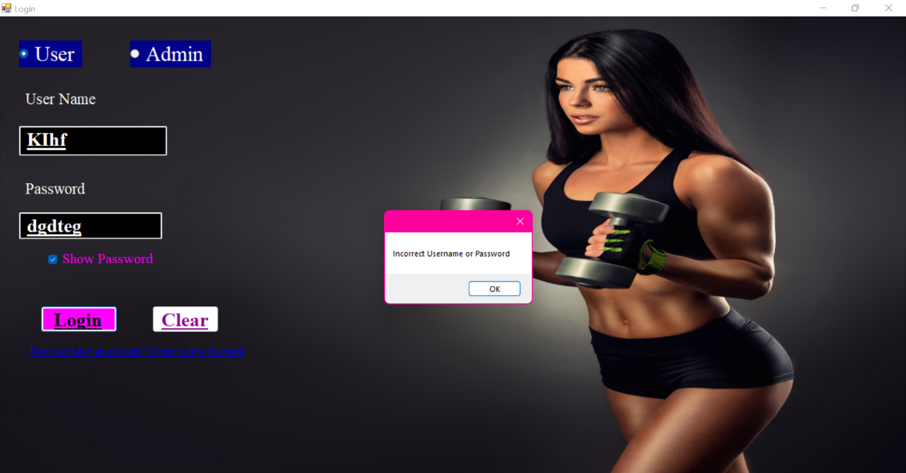

|  |  |  |  |
| --- | --- | --- | --- |
| **Case Number** | **Case** | **Process** | **Result** |
| **1** | **Signup validation for every record** | **Missing to fill all information** | **Error Message Box Will Display** |
| **2** | **Signup successful** | **After Filling all fields, click signup button** | **Success Message Box will display** |
| **3** | **Login Form** | **Enter registered name and passwords** | **Success Message Box will display** |
| **4** | **To appear Fitness program box** | **Clicking Ok button at Message Box** | **Fitness software will display** |

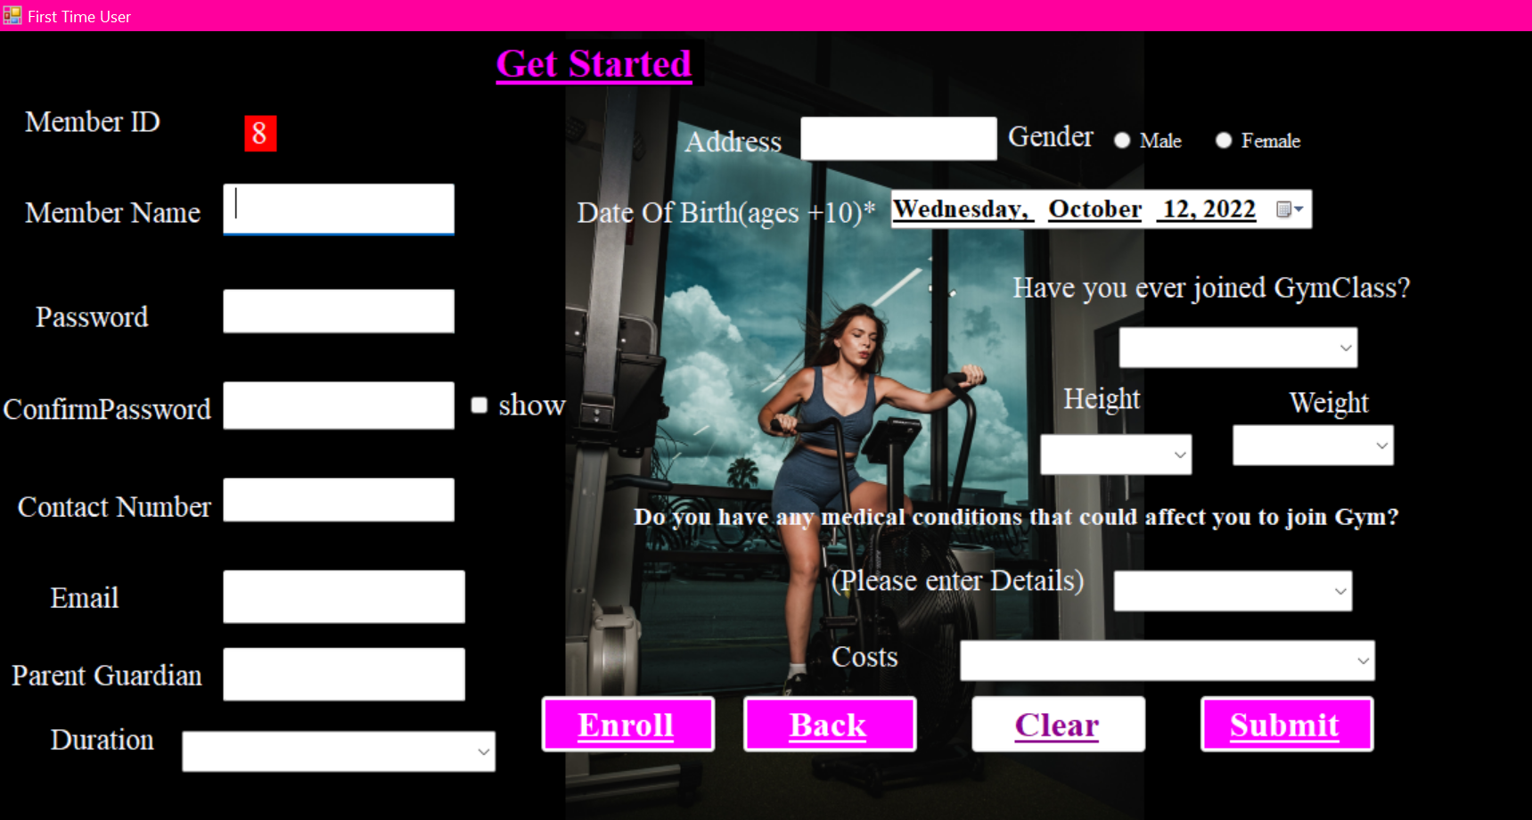

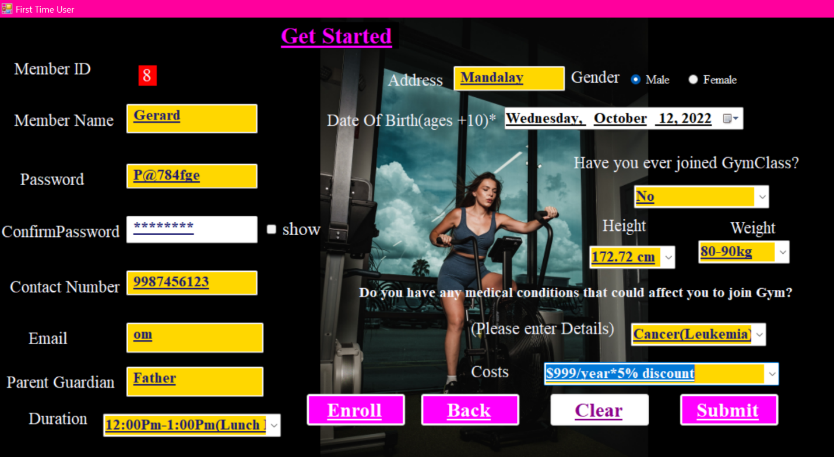

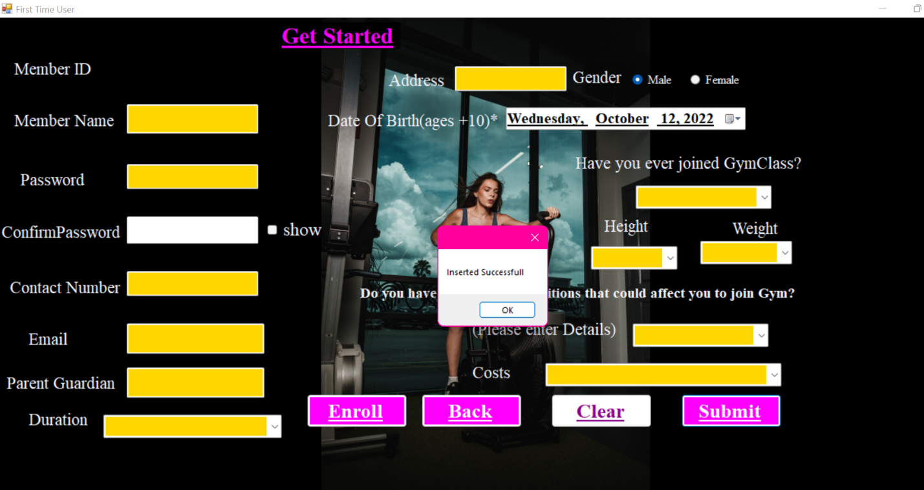

# 



|  |  |  |  |
| --- | --- | --- | --- |
| **Case Number** | **Case** | **Process** | **Result** |
| **1** | **Signup Validation for every statistic** | **Missing to fill all information** | **Error Message box will display** |
| **2** | **Submit button** | **-Member**  **-Select Class want to enroll**  **-Trainer Name**  **-Select Gender**  **-Enrollment Duration**  **Select Trainer Session** | **-Information will be added to Enrollment Table in Database**  **-Inserted successfully** |
| **3** | **Back button** | **Go back to fitness program form** | **Go back Function** |

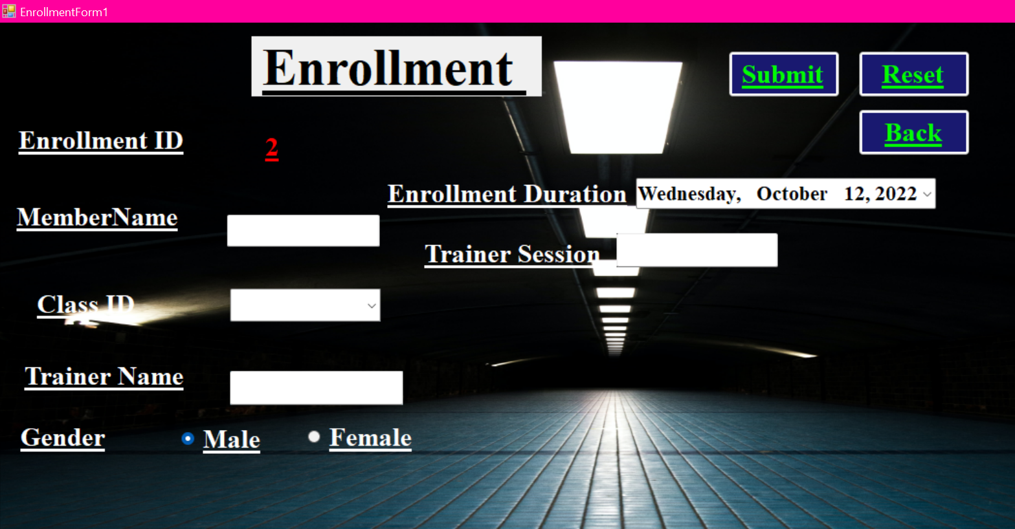

|  |  |  |  |
| --- | --- | --- | --- |
| **Case Number** | **Case** | **Process** | **Result** |
| **1** | **Validation** | **Missing to fill all data** | **Error Message Box will appear** |
| **2** | **Inserted Successfully** | **After Filling all fields, Click Insert Button** | **Success Message will display** |
| **3** | **To View within the database** | **Clicking the Insert button to look grid view** | **Staff Detail information will appear** |





|  |  |  |  |
| --- | --- | --- | --- |
| **Case Number** | **Case** | **Process** | **Result** |
| **1** | **Validation** | **Missing to fill Id to insert** | **Error Message Box will appear** |
| **2** | **Fill Update Data** | **Search data from grid view** | **Automatically to be appear** |
| **3** | **Viewing Successfully** | **After making important change click View** | **Success Message box will show** |
| **4** | **To insert the alternative in Database** | **Clicking the Insert button to move to another form** | **Staff Detail information will appear** |





|  |  |  |  |
| --- | --- | --- | --- |
| **Case Number** | **Case** | **Process** | **Result** |
| **1** | **Validation** | **Missing to fill Id to update** | **Error Message Box will appear** |
| **2** | **Fill Update Data** | **Click data from grid view** | **Automatically to be appear** |
| **3** | **Updating Successfully** | **After making important change click update view** | **Success Message box will show** |
| **4** | **To insert the alternative in Database** | **Clicking the Update button to update** | **Class Detail information will appear** |





|  |  |  |  |
| --- | --- | --- | --- |
| **Case Number** | **Case** | **Process** | **Result** |
| **1** | **Validation** | **Missing to fill Id to delete** | **Error Message Box will appear** |
| **2** | **Fill delete Data** | **Click data from grid view** | **Automatically to be appear** |
| **3** | **Deleting Successfully** | **Click the delete button** | **Success Message box will show** |
| **4** | **To view the alternative in Database** | **Clicking the view button to update** | **Member deleted area Detail information will appear** |